**M S Ramaiah Institute of Technology**

(An Autonomous Institute, Affiliated to VTU)

MSR Nagar, MSRIT post, Bangalore-54

**Design of**

**Single Pane Management of Cloud Email Security**

Submitted by

**Kush Bavishi 1MS12CS049**

Under the guidance of

|  |  |  |
| --- | --- | --- |
| **Suresh Gopathy**  **Technical Leader**  **Cisco Systems, Inc.**  **Bangalore** | **&** | **S. Rajarajeswari**  **Assistant Professor**  **Department of Computer Science & Engineering** |



**DEPARTMENT OF COMPUTER SCIENCE & ENGINEERING**

**M.S.RAMAIAH INSTITUTE OF TECHNOLOGY**

**(Autonomous Institute, Affiliated to VTU)**

**BANGALORE-560054**

[www.msrit.edu](http://www.msrit.edu)

**INTRODUCTION**

**Organization of the Document**

1. Architecture Design
2. Graphical User Interface
3. Sequence Diagram
4. References

**ARCHITECTURE DESIGN**

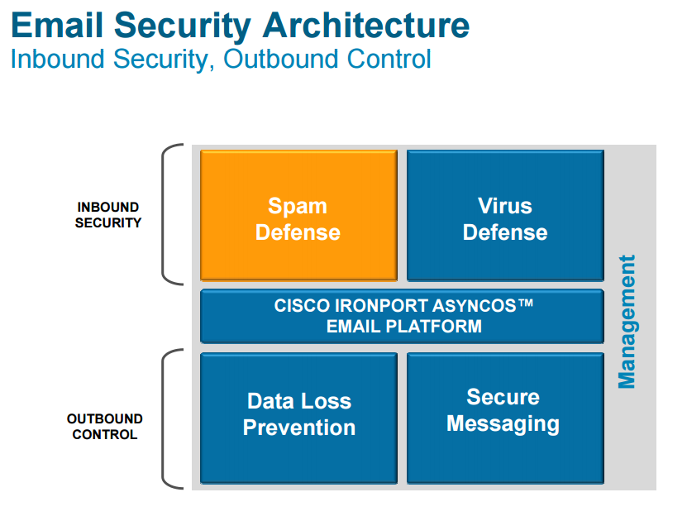

**Fig. ESA Architecture**

**GRAPHICAL USER INTERFACE**

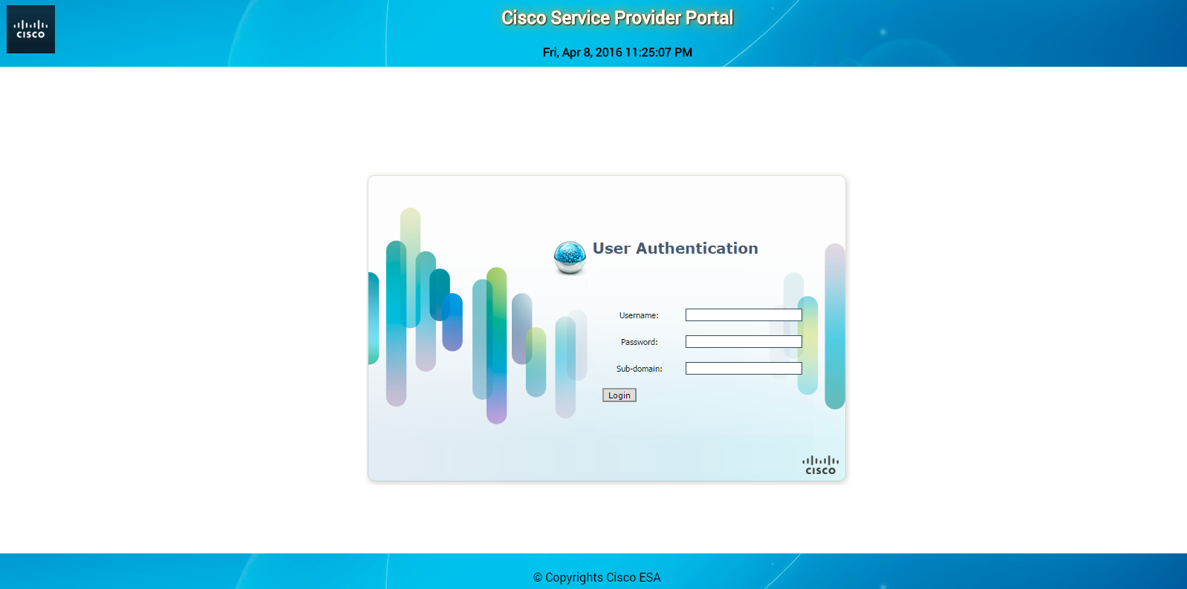

**Fig. Login Page**

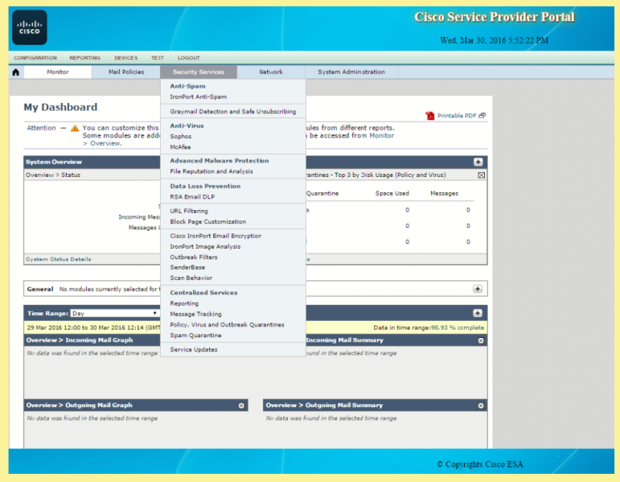

**Fig. Configuration Page**

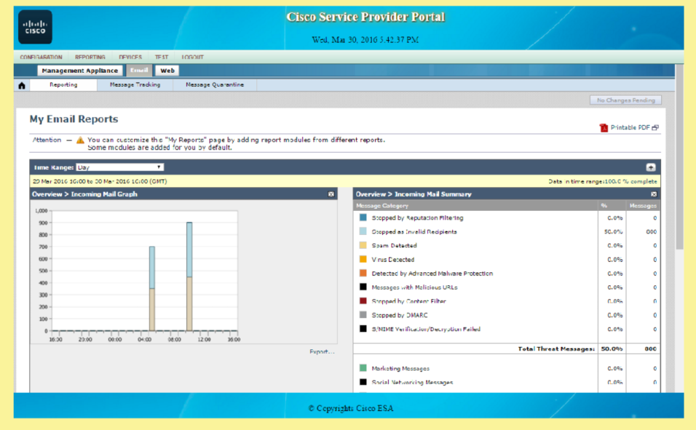

**Fig. Reporting Page**

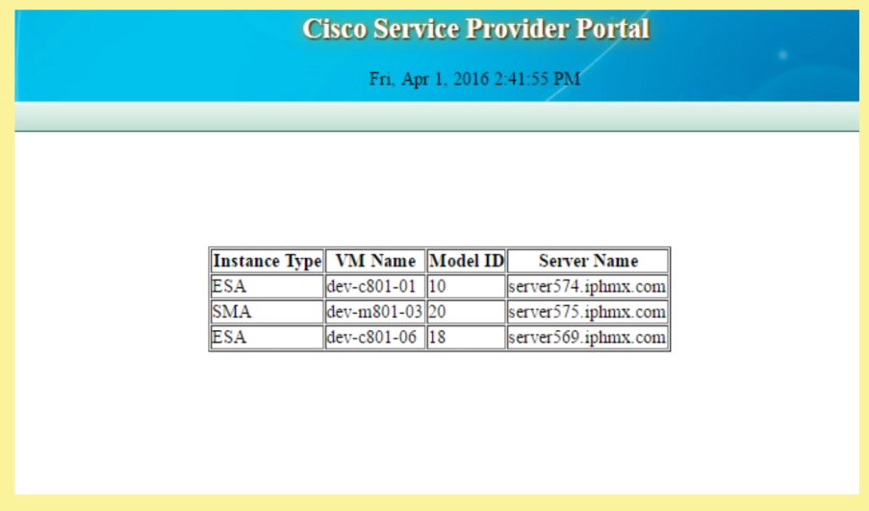

**Fig. Devices Page**

**SEQUENCE DIAGRAM**

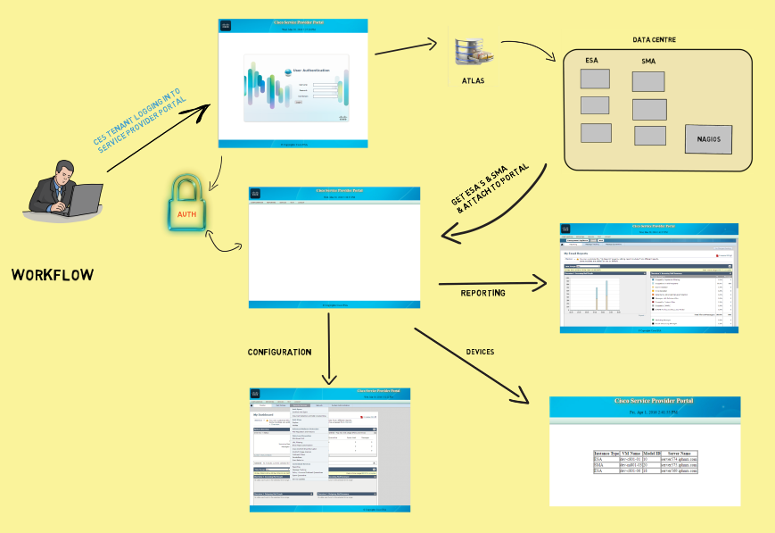

**Fig. Overall Workflow**

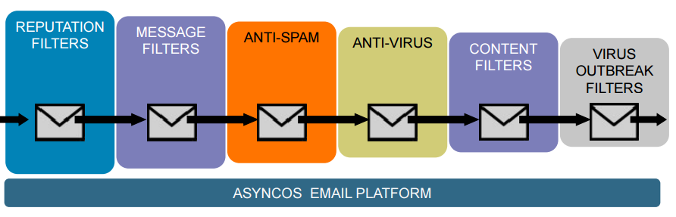

**Fig. Email Filtering Stages**

**REFERENCES**

* <https://wiki.cisco.com>
* <https://www.cisco.com>
* [www.wikipedia.org](http://www.wikipedia.org)